Web Pages:
1. The Homepage
2. Geopolitical Journal
3. The Lab
4. The Classroom
5. About Me
Web Pages Details:
1. The Homepage
Poem
Tagline:
2. Geopolitical Journal
Dispatches on Narrative & Power
National Security Cinema: Hollywood as a Geopolitical Apparatus
I. The Early Cold War: Anti-Communist Paranoia (1940s–1950s)
II. Subverting the Cold War Consensus
III. The Late Cold War: Hypermasculinity & Resurgence (1980s)
IV. Post-Cold War Chaos: Shifting the Enemy Geography (1980s–1990s)
V. Post-9/11: Trauma and the War on Terror
Concluding Thoughts
3. The Lab
The Lab: Narrative Topographies
The Lab Manifesto
Active Experiments:
Archived Experiments:
MPhil: The Collapse of Multiculturalism in Europe
Title: The Collapse of Multiculturalism in Europe: A Eurocentric Analysis of Dystopian Fiction
Fields of Study: World Literature, Political Philosophy, Multiculturalism, and Speculative Fiction.
Research Overview
Methodology
The Dataset: Classical Speculative Models
The Dataset: The 21st-Century Topography
Key Findings
Conclusion & Academic Significance
MA:The Cutting Edge of Speculative Fiction
Title: Michael Crichton’s Congo (1980): The Cutting Edge Speculative Fiction
Fields of Study: Contemporary English Literature, Speculative Fiction, Techno-Thriller Dynamics, and Literature of Science & Technology.
Research Overview
Methodology & Narrative Mechanics
Key Research Findings
Conclusion & Literary Significance
Publications
Peer-Reviewed Publications
Title: Geopolitical Tropes and Popular Geopolitics: The Great Game and Historical Narrative in Rudyard Kipling's Kim (1901)
Title: Cultural Debate in the 21st Century on Declining Multiculturalism in Europe
Book Reviews
Review of 'The End of the World Is Just the Beginning: Mapping the Collapse of Globalization' by Peter Zeihan (2022)
Review of 'The Politics of Crisis in Europe' by Mai'a K. Davis Cross (2017)
Book Chapter
4. The Classroom
Teaching Philosophy & Certifications
Global Certification:
Pedagogical Philosophy
Current Instruction
Previous Courses Taught
Literary Studies & Critical Theory
Linguistics, Stylistics & Pedagogy
Academic Writing & Discourse
Resources
The Living Archive
Signature Course Highlight
Classical Novel: Austen and the Mechanics of Adaptation
Literary Criticism: Applied Frameworks and Textual Evaluation
5. About Me
The Scholar
The Educator
The Institutional Leader
Research Trajectory
Grants & Fellowships
Future Horizons

Web Pages:

The Homepage

Geopolitical Journal

The Lab

The Classroom

About Me

Web Pages Details:

The Homepage

Poem
Two roads diverged in a wood, and I—
I took the one less traveled by,
And that has made all the difference.

Robert Frost (The Road Not Taken)

Tagline:
Decoding Global Power through Stories.

Geopolitical Journal

Dispatches on Narrative & Power
Welcome to the Geopolitical Journal. This space serves as an active, living repository for shorter analyses, contemporary commentary, and immediate reflections on the intersection of literature, mass media, and statecraft.
Here, I publish essays and commentary across my core areas of interdisciplinary study:
- Popular Geopolitics in Real-Time: Analyzing how current geopolitical events and civilizational divides are framed by mass media and public discourse.
- The Spatial Humanities: Brief explorations into how borders, internal migration, and physical geographies are continually reimagined in contemporary culture.
- Tropes & Statecraft: Deconstructing the rhetorical shortcuts and narrative frameworks used by policymakers to justify or explain global strategy.

National Security Cinema: Hollywood as a Geopolitical Apparatus
Reading the Spatialization of Threat in Modern Film
When analyzing how global power dynamics are constructed through narration, it is impossible to ignore the cinematic topography of Hollywood. While my primary datasets often focus on literary fiction, visual media serves as a highly potent infrastructure for manufacturing geopolitical consent.
Drawing heavily on the frameworks outlined in Klaus Dodds’ Geopolitics: A Very Short Introduction (2019), this dispatch categorizes the evolution of "national security cinema." By mapping how Hollywood has historically shifted its geographical imagination, we can observe the deliberate spatialization of the "enemy" and the use of film to rationalize American foreign policy across distinct geopolitical eras.

I. The Early Cold War: Anti-Communist Paranoia (1940s–1950s)
During this period, the boundaries between the entertainment industry and the state apparatus were remarkably porous. Hollywood collaborated directly with government agencies to cultivate a domestic fear of Soviet subversion and communist infiltration.
- Covert Funding & Metaphorical Threats: The CIA secretly funded the animated adaptation of Animal Farm (1954) to critique the Russian Revolution. Simultaneously, science fiction served as a subtle geopolitical proxy. Films like The Thing (1951) and Red Planet Mars (1952) weaponized the fear of extraterrestrial invasion as a direct metaphor for communist infiltration.
- The Domestic Frontline: My Son John (1952) moved the ideological battleground into the American home, warning of the vulnerability of American youth to Marxist ideologies.
- The Pentagon Partnership: The Longest Day (1961) highlighted active military-cinematic cooperation, enjoying heavy Pentagon backing (even as real-world crises in Berlin temporarily disrupted military availability on set).

II. Subverting the Cold War Consensus
Not all narrative discourse served the dominant conservative strategy. Several filmmakers utilized their platforms to critique the nuclear arms race and the xenophobia driving the House Un-American Activities Committee (HUAC).
- Satirical Pushback: High Noon (1952) operated as a structural critique of the HUAC blacklists, while It Came from Outer Space (1953) inverted the alien invasion trope to condemn small-town American xenophobia.
- Questioning Deterrence: The strategic logic of mutually assured destruction was effectively dismantled in On the Beach (1959), which depicted the bleak reality of nuclear annihilation, and famously ridiculed in Stanley Kubrick’s Dr. Strangelove (1964).

III. The Late Cold War: Hypermasculinity & Resurgence (1980s)
As Cold War anxieties were reignited under the Reagan administration, cinematic narratives pivoted away from existential dread and toward aggressive, hypermasculine statecraft and technological superiority.
- The Triumphalist Aesthetic: Films such as Top Gun (1986), Firefox (1984), and Rambo: First Blood Part II (1986) operated as celebrations of American military prowess against largely unnamed or explicitly communist adversaries.
- The Ultimate Spatial Violation: Red Dawn (1984) modeled a theoretical worst-case geopolitical variable: a joint Soviet-Cuban invasion of the American Midwest, neutralizing traditional military structures to rely on the patriotic insurgency of local high school students.

IV. Post-Cold War Chaos: Shifting the Enemy Geography (1980s–1990s)
With the collapse of the Soviet Union, the geopolitical binary of the Cold War dissolved. Hollywood was forced to rapidly re-map the global threat architecture, pivoting toward the Middle East, rogue states, and post-Soviet fragmentation.
- The Fractured East: Films like GoldenEye (1995), The Peacemaker (1997), and Air Force One (1997) spatialized the former Soviet bloc not as a unified empire, but as a chaotic vacuum generating rogue terrorism and arms trafficking. Conversely, The Hunt for Red October (1990) softened the Russian adversary by depicting a Soviet captain defecting in pursuit of the "American Dream."
- The Middle Eastern Tropes: Iron Eagle (1986) and Navy SEALs (1990) began heavily shifting the narrative backdrop toward the Middle East. By the late 90s, The Siege (1998) and Rules of Engagement (2000) sparked significant backlash for cementing a reductive, anti-Western trope of Arabs and Muslims, effectively laying the cultural groundwork for post-9/11 policies.
- The Domestic Terror Threat: Speed (1994) and The Rock (1996) briefly turned the lens inward, exploring domestic terrorism executed by disenfranchised American military and law enforcement personnel.

V. Post-9/11: Trauma and the War on Terror
The cinematic output surrounding 9/11 served dual purposes: providing national catharsis and justifying a unilateral global response.
- Foreshadowing & Catharsis: Collateral Damage (2002) and The Sum of All Fears (2002) eerily anticipated catastrophic attacks on American soil. Later, United 93 (2006) and World Trade Center (2006) processed the real-world trauma by focusing strictly on American heroism and victimhood.
- Validating Unilateral Statecraft: Behind Enemy Lines (2001) argued a distinct geopolitical thesis: that American exceptionalism requires unilateral military action, even if it means ignoring international mandates.
- Direct Geopolitical Utility: Visual media's role in policy was explicitly confirmed when President George W. Bush referenced the Iranian film Kandahar (2001) to publicly justify US military intervention against the Taliban. Meanwhile, Michael Moore’s Fahrenheit 9/11 (2004) attempted unsuccessfully to utilize documentary film as a direct intervention in the 2004 presidential election.

Concluding Thoughts
What Dodds’ analysis reveals is that pop culture is never merely a reflection of the times; it is active narrative infrastructure. By continuously re-mapping geopolitical tropes from the godless communist to the chaotic rogue state Hollywood has played a foundational role in shaping the American public's geographical imagination and manufacturing consent for shifting global strategies.

The Lab

The Lab: Narrative Topographies

The Lab Manifesto
In this lab, literature serves as the primary data.
From my foundational MPhil work to my current PhD research, I treat fictional narrative landscape as a primary datasets to map structural power, imperial tropes, and statecraft.

Active Experiments:
PhD: Narrative Discourse and Global Power Dynamics
Current focus for doctoral dissertation is Interdisciplinary Social Sciences particularly Geopolitics, Popular Geopolitics, World Literature,and History
Topic: Geopolitics and Global Narration (1979–2026)
Bridging International Relations and Comparative Literature to understand how fiction shapes public perception of global power.
Primary Datasets: Narrative Topographies (Literature-Novels/Fiction)
The current experimental corpus for this research comprises distinct narrative environments published between 1979 and 2012. Rather than a singular genre, the dataset is deliberately cross-sectional to map how structural power, statecraft, and imperial tropes adapt across different narrative frameworks.
The texts are classified into the following geopolitical topographies:
- The Intelligence & Espionage Archive: Includes works of Cold War Espionage, Historical Espionage, and Post-9/11 Espionage.
These texts serve as testing grounds for analyzing how intelligence apparatuses, military fiction, and covert statecraft are spatialized within literature.
- Post-9/11 Discourse & Political Thrillers: Includes Political Thrillers, Postmodern Political Fiction, and Post-9/11 Fiction.
These narratives provide a framework to examine the shift in global hegemony, the spatialization of the "enemy," and the disruption of structural power in the 21st century.
- Speculative & Satirical Tales: Includes Political Satire, Hard Sci-Fi, and Speculative Fiction.
These topographies act as extreme variables in the experiment, to model the theoretical limits of classical geopolitical doctrines.

Archived Experiments:

MPhil: The Collapse of Multiculturalism in Europe



Title: The Collapse of Multiculturalism in Europe: A Eurocentric Analysis of Dystopian Fiction

Fields of Study: World Literature, Political Philosophy, Multiculturalism, and Speculative Fiction.

Research Overview
This foundational thesis analyzes contemporary European responses to multiculturalism and ethnic anxiety, investigating how these themes are depicted across modern dystopian world literature. It critically interrogates the perceived failure of multiculturalism in 21st-century Europe by examining the complex interplay between immigration, demographic imbalance, and the erosion of social cohesion. By addressing how Western societal structures have struggled to balance cultural diversity with national identity, the research maps the sociopolitical fractures that have catalyzed the rise of right-wing populism and left-wing identity politics.

Methodology
Adopting a qualitative, hermeneutic approach, this study treats literature not merely as speculative entertainment, but as an active diagnostic tool. The methodology utilized an expansive corpus of seven major works. The research bridged three classical dystopian texts with four contemporary novels to map the trajectory of European integration, identity crises, and spatial displacement over time.

The Dataset: Classical Speculative Models
These foundational texts established how 20th-century authors projected future demographic and existential crises:
- Jean Raspail (The Camp of the Saints, 1973): Analyzed for themes of mass migration and the breakdown of societal structures under demographic pressure.
- Anthony Burgess (1985, 1978): Examined the transformation of the British social landscape under the weight of shifting cultural influences and union dominance.
- P.D. James (The Children of Men, 1992): Explored authoritarian statecraft and the political response to the existential crisis of global demographic decline.

The Dataset: The 21st-Century Topography
This extended section investigated how contemporary literature operates as a stress test for immediate sociopolitical challenges, mapping the crisis across four distinct national lenses:
- British Fiction Rob Sinclair (Sleeper 13, 2018): Analyzed the intersection of espionage and societal fragmentation, modeling the complex, real-world friction of assimilation and the potential for localized socio-political instability within urban centers.
- French Fiction Michel Houellebecq (Submission, 2015): Examined as a speculative political narrative interrogating the resilience of Western democratic values and the fraught ideological boundaries between secular liberalism and religious frameworks.
- German Fiction Jenny Erpenbeck (Go, Went, Gone, 2015): Positioned as a humanistic counter-narrative mapping the trauma of displacement, challenging systemic biases by centering the empathy required in the asylum process.
- South Asian Fiction Mohsin Hamid (Exit West, 2017): Investigated for its spatial perspectives on the "migration journey," analyzing how large-scale refugee movements actively rewrite the social architecture and physical landscapes of Western metropolises.

Key Findings
- The Implementation Gap: While multiculturalism aims to foster tolerance, its practical implementation in Europe has faced profound systemic obstacles, leading to fragmented enclaves rather than a cohesive social fabric.
- Literary Foresight: The selected corpus successfully anticipated modern tensions across the UK, France, and Germany, proving that dystopian fiction is an accurate predictive lens for the politicization of immigration and polarized national identity.
- The Need for Nuanced Dialogue: The "multicultural crisis" is not a monolith; it is a multifaceted emergency driven by historical, economic, and security-related factors that demand interdisciplinary analysis.
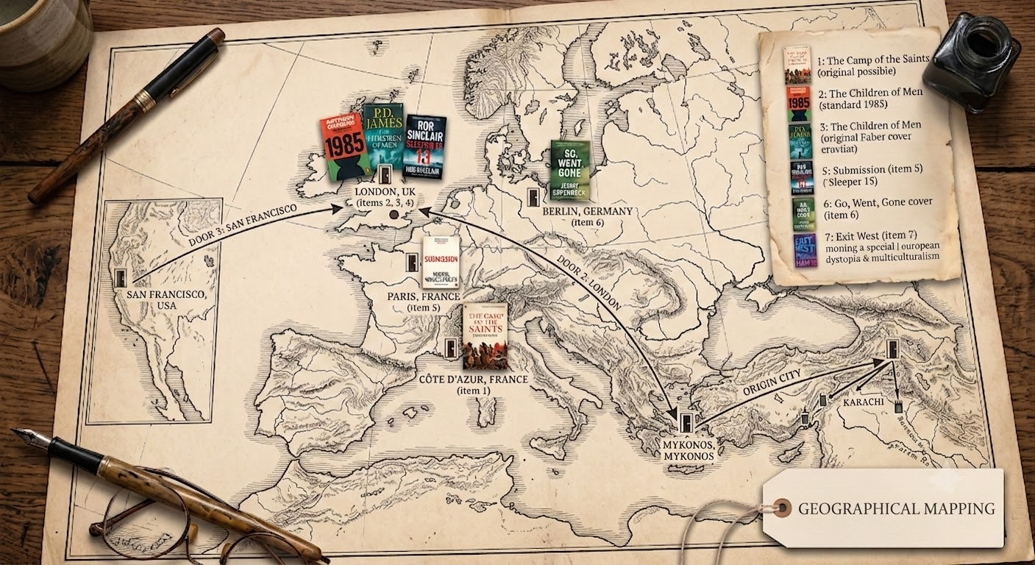

Conclusion & Academic Significance
The study concludes that while multiculturalism remains a noble ideal, current policies require rigorous, reality-based re-evaluation. By moving beyond traditional political science and utilizing literature as a critical geopolitical dataset, this research advocates for a deeply interdisciplinary approach to global challenges. Speculative fiction ultimately serves as a vital tool for understanding the human condition, fostering empathy, and addressing the urgent, ongoing challenge of engineering inclusive, sustainable societies in a rapidly shifting world.

MA:The Cutting Edge of Speculative Fiction
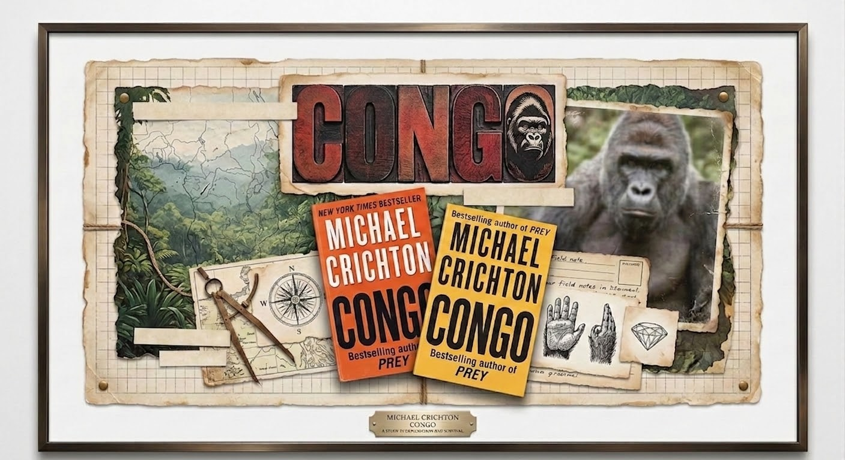

Title: Michael Crichton’s Congo (1980): The Cutting Edge Speculative Fiction

Fields of Study: Contemporary English Literature, Speculative Fiction, Techno-Thriller Dynamics, and Literature of Science & Technology.

Research Overview
This research examines Michael Crichton’s 1980 novel Congo as a foundational text in modern speculative fiction. The thesis argues that Crichton redefined the "techno-thriller" by systematically eroding the boundaries between empirical scientific fact and speculative narrative. By blending traditional imperial "Lost World" adventure tropes—such as the pursuit of legendary diamond deposits and unmapped primate species—with contemporary technological discourse, the study analyzes how the novel functions as an early critique of corporate-scientific hubris and the ethical dilemmas of emerging biotechnologies.

Methodology & Narrative Mechanics
Adopting a qualitative, hermeneutic approach, the study investigates the structural mechanics Crichton uses to induce a "willing suspension of disbelief." The thesis dissects Crichton's signature Fiction-as-Fact methodology:
- Pseudo-Documentary Framing: The strategic deployment of bibliographic citations, faux-academic references, computer code, and annotated data graphs to give speculative fiction the weight of authentic historical documentation.
- Subversion of Tropes: The re-calibration of classic late-19th-century adventure narratives to mirror modern industrial espionage, satellite mapping, and automated field technology.

Key Research Findings
- Architect of the Techno-Thriller: The thesis positions Crichton as a pivotal figure who elevated popular genre fiction into a sophisticated platform for analyzing real-world scientific advancement.
- Critique of Scientific Hubris: Beyond high-stakes narrative pacing, the novel serves as a warning against "playing God," illustrating the unintended consequences of environmental exploitation, corporate greed, and uncontrolled industrial science.
- Pedagogical & Cultural Value: The research establishes that popular speculative narratives are critical cultural artifacts, equipping readers with the analytical tools to question society's evolving dependence on rapid technological acceleration.

Conclusion & Literary Significance
The study concludes that Congo bridges high-stakes adventure and literary realism. By embedding rigorous technical discourse within popular storytelling, the novel proves that speculative fiction is uniquely equipped to interrogate the moral, environmental, and societal risks of the late-20th and 21st centuries.

Publications

Peer-Reviewed Publications

Title: Geopolitical Tropes and Popular Geopolitics: The Great Game and Historical Narrative in Rudyard Kipling's Kim (1901)
Journal: Journal of European Studies (July 2026) DOI: https://doi.org/10.56384/jes.v42i2.445
Research Overview This recently published 6,500-word study explores the function of "geopolitical tropes"—figures of speech operating at the intersection of geography and political power. It argues that these tropes serve as cognitive shortcuts, compressing complex, multilateral dynamics into zero-sum binaries that make global affairs accessible to the public while often obscuring ground realities. By tracing the evolution of "The Great Game" from a 19th-century imperial rivalry to a contemporary descriptor for superpower competition, the article highlights literature's foundational role in manufacturing geopolitical consent.
Theoretical Framework The study applies a dual analytical framework to dissect how popular culture actively influences foreign policy:
- Critical Geopolitics: Utilized for macro-level analysis, exposing how geography is politically inscribed and mapped by the powerful to justify statecraft and foreign interventions.
- Narrative Theory: Applied as a micro-level tool to decode the technical architecture of storytelling (such as plot, pacing, and character archetypes) to understand how these fictions successfully persuade mass audiences.
Key Findings: The Case of Kim (1901)
- Literature as Narrative Infrastructure: The analysis reveals that Kipling’s text operates not as neutral entertainment, but as active narrative infrastructure. By centering on a hybrid protagonist whose local expertise serves British strategic interests, the novel normalizes the Anglo-Russian rivalry as a heroic quest rather than raw imperial strife.
- Constructing Civilizational Binaries: The novel engineers a spatial hierarchy where India is depicted as fragmented and irrational (justifying British rule as a necessary ordering force), while Russia is cast as a tyrannical "Other" (validating British military expansionism as a purely defensive measure).
- Geopolitical Enculturation: The immense popularity of Kim implanted long-lasting imperial tropes into the collective consciousness, ultimately providing British policymakers with a cultural framework to justify military spending and regional interventions.
Contemporary Relevance: Popular Geopolitics 2.0 The study concludes by bridging historical literary analysis with the modern digital age. Today, the boundaries between elite discourse and popular understanding are highly porous. As the world navigates a period of deglobalization and renewed superpower rivalries, dominant paradigms like "Great Power Competition" and the "Thucydides Trap" function exactly as "The Great Game" did. The research demonstrates that geopolitical tropes remain a powerful, double-edged sword capable of rapidly shifting public sentiment and escalating global tensions in an era of accelerated media consumption.

Title: Cultural Debate in the 21st Century on Declining Multiculturalism in Europe
Journal: Journal of European Studies (July 2024)
DOI: https://doi.org/10.56384/jes.v40i2.348
Impact & Metrics: Cited Article (h-index Contribution: 1)
Research Overview
This study interrogates the crisis of social cohesion and cultural conflict across 21st-century Europe. The research establishes a theoretical intersection by synthesizing three distinct analytical frameworks: the policy failures of European multiculturalism, the resurgence of Ibn Khaldun’s concept of asabiyyah (group solidarity), and Samuel P. Huntington’s "Clash of Civilizations" thesis. The article asserts that in a post-9/11 and post-industrial landscape, primordial attachments—such as religion, language, and ancestral identity—have superseded traditional political ideologies as the primary drivers of both localized conflict and global statecraft.
Theoretical Triad
- The Multicultural Crisis: Analyzes how economic recessions, resource competition, and demographic shifts have fractured European integration frameworks (from French assimilationism to British multiculturalism), leading to systemic social exclusion and political polarization.
- The Resurgence of Asabiyyah: Adapts Ibn Khaldun’s 14th-century sociological model to modern state dynamics, arguing that contemporary nationalism, localism, and right-wing populism represent a protective revival of asabiyyah—a reactionary group solidarity deployed against perceived cultural dilution and globalization.
- Civilizational Fault Lines: Integrates Huntington’s framework to demonstrate how internal social fragmentation within European nation-states mirrors broader, macro-level civilizational friction between "Core States" and "kin countries."
Key Findings & Contemporary Impact
- Validation of Civilizational Divides: The research proves that the perceived collapse of European multiculturalism operates as a localized stress test, validating civilizational fault-line theories in everyday sociopolitical life.
- Modernization vs. Westernization: The study highlights a growing global decoupling where non-Western societies and migrant communities achieve technological and economic modernization without adopting Western secular liberalism.
- Digital Asabiyyah & Virtual Polarization: Explores how digital media simultaneously constructs a global youth subculture while accelerating virtual polarization, creating new online "fault lines" that mirror real-world geopolitical tensions.
Conclusion & Policy Implications
The article warns that as the international order transitions into an era of deglobalization and shrinking resources, the friction between declining multiculturalism, hyper-nationalist asabiyyah, and civilizational divides risks devolving into a zero-sum conflict. The study concludes that sustainable global stability requires moving away from zero-sum integration models toward intentional, reality-based intercultural dialogue and structural inclusivity.

Book Reviews

Review of 'The End of the World Is Just the Beginning: Mapping the Collapse of Globalization' by Peter Zeihan (2022)
Journal: Journal of European Studies (Jan 2024)
DOI: https://doi.org/10.56384/jes.v40i1.337
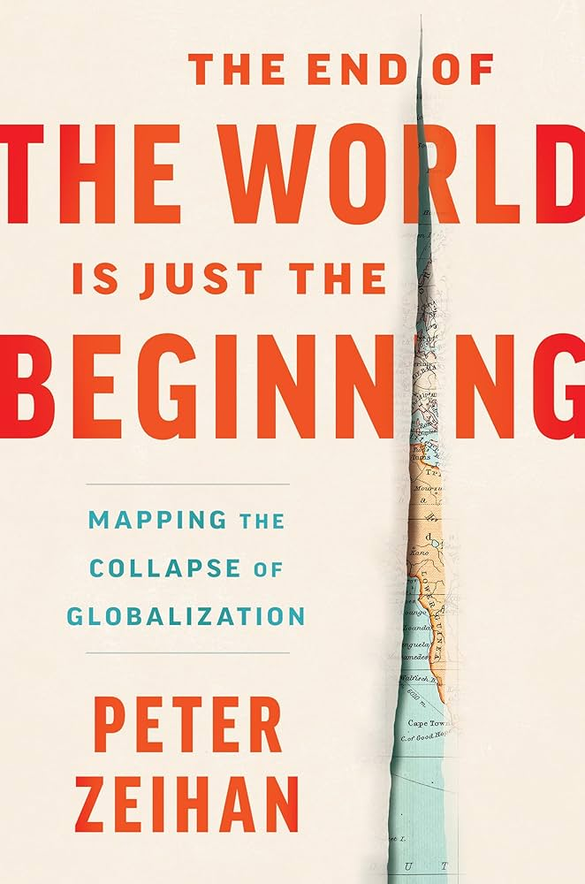
Review Overview & Core Thesis This published review analyzes Peter Zeihan’s 2022 geopolitical forecast, which predicts the impending collapse of the US-enforced, post-WWII globalized trading system. The review evaluates Zeihan's core argument: as the United States retreats from its role as the global security guarantor, nations will be forced to abandon global competition and restructure to independently secure domestic food, manufacturing, and energy. The review highlights Zeihan's focus on geography and demographic collapse—specifically rapidly aging and shrinking populations—as the primary drivers of this deglobalization.
Structural Analysis of the Text The review systematically breaks down Zeihan’s seven-part framework, tracing the transition from historical integration to future localized survival:
- The Breakdown of 'The Order' (Sections I-III): Examines the historical establishment of US global hegemony and the demographic shifts making current transport, maritime trade, and global financial models unsustainable.
- Resource Dependency (Sections IV-V): Analyzes the modern reliance on US-managed supply chains for fossil fuels and industrial materials, noting that the transition to "Greentech" is structurally hindered by geographic and infrastructural limitations.
- Production & Survival (Sections VI-VII): Evaluates Zeihan's predictions regarding mass production and agriculture, emphasizing that complex supply chains will fracture. Success will depend on regional connectivity, while the breakdown of specialized agricultural transport threatens severe global food insecurity.
Conclusion & Strategic Outlook The review concludes by assessing Zeihan's geopolitical forecast: the end of globalization does not signal a return to pre-industrialism, but rather a harsh recalibration where survival is dictated by localized geography, transport, and demographics. The analysis notes that Zeihan envisions a gradual systemic decay—ending "not with a bang but a whimper"—driven by protectionist policies and systemic withdrawals, inevitably triggering inflation and disrupted supply chains on a global scale.

Review of 'The Politics of Crisis in Europe' by Mai'a K. Davis Cross (2017)
Journal: Journal of European Studies (Jan 2020)
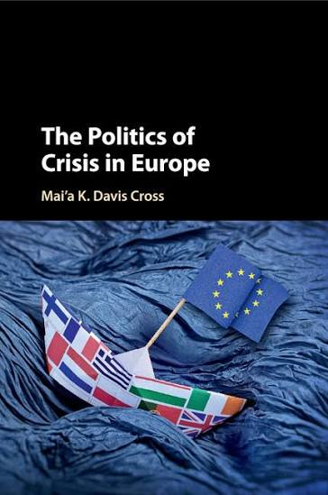
Review Overview & Core Thesis This published review evaluates Mai'a K. Davis Cross’s 2017 analysis of European integration and institutional resilience. The review highlights Cross’s central argument: rather than signaling the collapse of the EU, structural crises trigger a state of "integrational panic"—amplified by media and political elites—that ultimately serves as a catalyst for deeper integration. The review unpacks Cross's focus on the power of "social narratives" and her tripartite analytical framework (systemic, behavioral, and sociological) to explain how public sentiment is actively shaped during periods of instability.
The Anatomy of Crisis & Case Studies The review systematically breaks down Cross’s predictable five-stage crisis model (Trigger, Buildup, Crisis Height, Catharsis, Resolution) by analyzing three major 21st-century European events:
- 2003 EU Iraq Crisis: Examines the initial fragmentation of the newly formed Common Foreign and Security Policy (CFSP) under post-9/11 US pressure, which ultimately resolved into a deeper, unified defense and security strategy.
- 2005 Constitutional Treaty Crisis: Analyzes the severe panic following the French and Dutch "no" votes, demonstrating how this democratic rejection ultimately paved a smooth path for the passage of the 2009 Lisbon Treaty.
- 2010 Eurozone Crisis: Highlights how the localized economic downturn in Greece (accounting for only 2% of the EU economy) was weaponized and magnified by elite narratives into an existential threat regarding the creditor North and debtor South.
Conclusion & Academic Significance The review concludes that Cross’s work provides a vital, thought-provoking counter-perspective to traditional political science. By demonstrating how media and elites politicize socially driven issues to manufacture existential panics, the book successfully dismantles popular "Doomsday scenarios" and offers a resilient, highly structural model of European political development.

Book Chapter
Chapter: World System Theory, Economic Migration, and Karachi: A Comparative Study, its Implications and Challenges
Book: Economic Migration: A Comparative Study, Its Implications And Challenges (2021)
ISBN: 978-969-8551-31-5
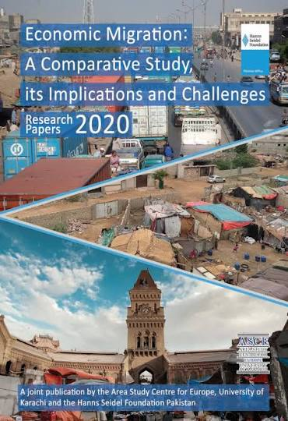
Research Overview
This interdisciplinary chapter investigates the macroeconomic frameworks and internal migration processes driving the demographic explosion of Karachi. The research critically assesses whether the city maintains the infrastructural capacity to support its continuous influx of economic migrants. By utilizing Immanuel Wallerstein’s World System Model and the Kondratieff Cycle, the study bridges macro-level economic theory with the on-the-ground realities of developing market economies.
Theoretical Framework & Economic Mapping
- The Semi-Periphery Buffer: Applying Wallerstein’s three-tier global capitalist model, the study positions Karachi as a highly vulnerable "semi-periphery" zone. It operates as a buffer where "Core" entities (multinational corporations) invest to exploit cheap labor, which in turn drives an unsustainable, one-way migration loop from Pakistan's underdeveloped "Periphery" (rural agrarian regions).
- The Kondratieff Cycle: The research maps Karachi's economic trajectory across 40-to-60-year economic waves, charting its transition from a post-independence industrial expansion phase into its current state of severe structural recession and municipal stagnation.
- Challenging Linear Growth: The chapter explicitly challenges Walt Rostow's linear stages of growth model, proving that in Karachi's reality, the wealth gap is widening, making traditional high-consumption economic forecasts unviable for managing the city's structural crises.
Key Findings: Socioeconomic Impact & Structural Collapse
- The Dual-Exploitation Dynamic: Karachi faces structural exploitation from both ends. Core entities extract profit while leaving behind environmental hazards, and internal migrants extract earnings to remit back to rural peripheries, effectively starving the local urban ecosystem of vital reinvestment.
- Infrastructure Failure: The unregulated 40-fold population explosion—from 450,000 in 1947 to over 20 million—has fractured municipal resources. This has driven the rise of sprawling informal settlements (katchi abadis) to house the informal sector, which employs 75% of the city's unskilled migrant workforce.
- Spatial and Ethnic Friction: Indigenous and established populations increasingly view the vast influx of internal labor as an invasion of local economic space, catalyzing intense political, ethnic, and sectarian conflicts over shrinking land and resources.
Policy Implications & Comparative Solutions
- Comparative Regulatory Models: The study analyzes alternative structural solutions, highlighting the Chinese Hukou registry system and high-speed transit networks as potential blueprints for restricting permanent city residency while allowing rural populations to commute without overpopulating the urban core.
- Rural Decentralization: The chapter argues for a rigorous overhaul of agricultural and fiscal policies to build sustainable infrastructure in rural provinces, thereby limiting the necessity of poverty-driven migration for "raw cash."
- Leveraging Macro-Projects: Sustainable future management relies on utilizing emerging megaprojects, such as the China-Pakistan Economic Corridor (CPEC) and new seaport developments, to actively redirect economic migrant flows away from Karachi and toward newly decentralized financial hubs.

The Classroom

Teaching Philosophy & Certifications

Global Certification:
University of Cambridge – EMI Skills (English as a Medium of Instruction)

Pedagogical Philosophy
My classroom operates as an active critical space. I believe in nurturing critical thinkers who can systematically deconstruct complex narratives. By combining rigorous linguistic analysis with creative engagement in literature and the arts, I equip students with the analytical tools to map and interrogate structural power in both fiction and reality. Ultimately, this approach translates traditional literary study into vital 21st-century skills, fostering the advanced critical thinking, media literacy, and adaptive reasoning required to navigate today’s complex global paradigms.

Current Instruction
- Arts & Humanities (HEC General Course)
- Foundation & Advanced English Integration: Comprehensive Certificate and Diploma courses focusing on core communicative competencies.

Previous Courses Taught

Literary Studies & Critical Theory
- Regional & Postcolonial: Pakistani Literature in English, Pakistani Anglophone Works, Translated Urdu Literature
- Core Literature: Modern Novel, Modern Drama, Classical Literature (Novel, Drama, Poetry)
- Specialized Frameworks: Literary Criticism, American Literature, Women's Literature

Linguistics, Stylistics & Pedagogy
- Applied Linguistics: Sociolinguistics, Psycholinguistics, English in Pakistan
- Textual & Structural Analysis: Stylistics, Phonetics and Phonology
- Instructional Design: Teaching Vocabulary and Grammar, Audio-Visual Aids & Adaptation of Material

Academic Writing & Discourse
- Advanced Composition: Academic Reading and Writing (Advanced Diploma level), Creative Writing
- Core Competencies: Functional English (Elementary and Advanced), Communication Skills, Mass Communication

Resources

The Living Archive
Course syllabi, reading lists, and pedagogical reflections for select modules are periodically updated and archived here for current students and fellow educators.

Signature Course Highlight

Classical Novel: Austen and the Mechanics of Adaptation
The Objective To move classical literature from static history into active, critical spaces by engaging with comparative studies and visual media.
Pedagogical Insight In this course, traditional, passive reading assignments are replaced with dynamic textual interrogation. Rather than analyzing a single text in isolation, students are challenged with comparative structural studies—for example, mapping the social and spatial dynamics of Pride and Prejudice against Austen’s wider bibliography.
Furthermore, media adaptations are not relegated to extracurricular homework; they are brought directly into the classroom laboratory. By conducting rigorous, scene-by-scene dissections of television and film adaptations, students learn to critically analyze how narrative, action, and structural power translate from the 19th-century page to the modern screen.

Literary Criticism: Applied Frameworks and Textual Evaluation
The Objective: To transition students from passive consumers of literary theory into active critics capable of rigorously evaluating a text's structural integrity.
Pedagogical Insight: In my classroom, theoretical frameworks are not merely memorized; they are put to work. I train students to actively apply classical methodologies—such as Aristotelian critique—to dissect and evaluate the merit of a text. By structuring assignments around targeted research questions (for example, interrogating whether a narrative structurally prioritizes plot mechanics over character development), students learn to identify the hierarchy of elements within a story. This approach empowers them to judge a work based on rigorous, objective criteria rather than subjective preference, equipping them with the analytical tools necessary for advanced scholarly research.

About Me
Rabia Mansoor
Independent Researcher
PhD Scholar
Google Scholar https://scholar.google.com/citations?user=ky8HvIEAAAAJ&hl=en
ORCID https://orcid.org/0009-0005-0134-9612
I am an independent researcher, educator, and academic administrator with grant-winning research and published scholarship. My niche lies in the interdisciplinary study of Classical Geopolitics, World Literature, popular geopolitics, and the spatial humanities.
My work focuses on analyzing how global power dynamics are constructed through narration. Specifically, my core intellectual pursuit is decoding how structural power, imperial narratives, and classical geopolitical frameworks are mapped and manifested in contemporary fiction and mass media.

The Scholar
My current PhD research in the Social Sciences investigates the active role of narrative discourse in shaping global power dynamics, with a particular focus on Cold War and post-9/11 literature, alongside spy thrillers. This work builds upon a foundation established during my MPhil in interdisciplinary research (graduating with a 3.68 CGPA).
My academic portfolio features a foreign research grant and peer-reviewed publications, including a book chapter, cited research, and Y-category journal book reviews. It also includes extensive textual analysis articles, such as mapping spatial tropes in classical works like Rudyard Kipling’s Kim.

The Educator
With over 11 years of experience teaching English Language, Linguistics, and Literary Studies at public sector universities, my classroom is an extension of my analytical research.
I am a Cambridge Certified EMI (English as a Medium of Instruction) instructor, a credential that reflects my commitment to maintaining global pedagogical standards. I specialize in training diverse student cohorts to transition from passive reading to active, theoretical interrogation of texts.

The Institutional Leader
Beyond research and teaching, I bring a strong background in academic administration. Having served as the Head of the Examination Department at a newly established university, I was responsible for foundational policy drafting, maintaining institutional integrity, and managing complex academic structures. I developed the department from its inception, successfully executing a complete academic cycle single-handedly.
This leadership experience provided me with a comprehensive, top-down understanding of higher education frameworks, ensuring that my approach to academia is both theoretically sound and structurally practical.

Research Trajectory
The Evolution of My Research: My academic journey represents a continuous, intentional progression in mapping complex systems through narrative. This trajectory began during my MA by examining the technological and speculative systems in Michael Crichton’s techno-thrillers. It expanded during my MPhil to analyze the sociopolitical and spatial systems underlying European dystopian fiction. Today, this foundational work culminates in my PhD research, which interrogates the geopolitical and power systems active within the Cold War and post-9/11 literature.

Grants & Fellowships
Hanns Seidel Foundation Research Fellowship
Project Focus: Internal Migration and Urban Infrastructure in Karachi Duration: Six-Month Funded Project
Awarded a competitive research fellowship by the Hanns Seidel Foundation to conduct a specialized, six-month project on internal economic migration. The research focused on the socioeconomic, demographic, and structural impacts of unchecked domestic migration on the urban infrastructure of Karachi, Pakistan.

Future Horizons
Presently, I am seeking to broaden my collaborative research network and am highly receptive to academic roles, interdisciplinary fellowships, and institutional partnerships. I am especially drawn to engagements situated within dynamic geopolitical and scholarly hubs, where the convergence of geography, statecraft, and cultural narration is most pronounced.

